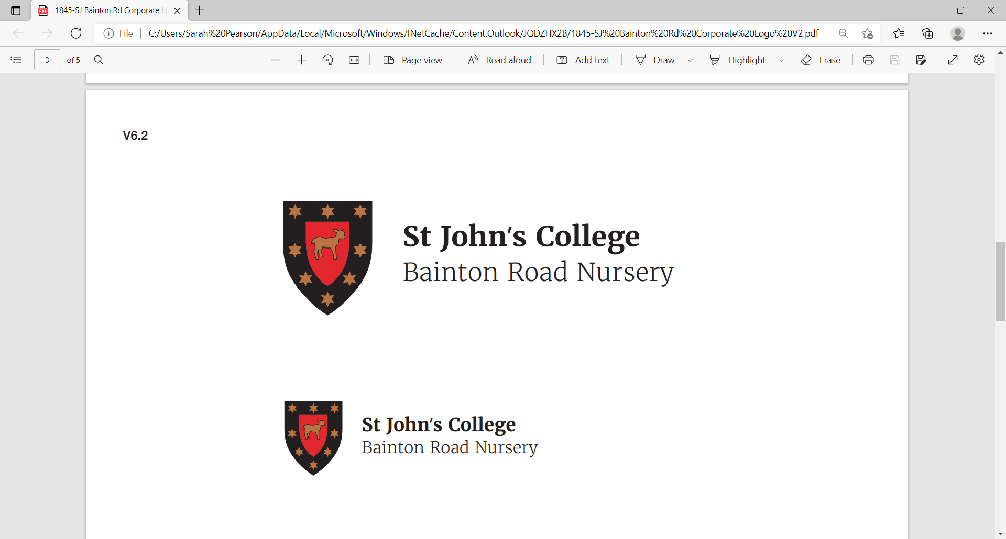

Nursery Assistant / Lunch Cover 20 Hours per week
(Maternity cover until April 2027)

Reports to:
The Nursery Manager and Deputy Manager.
Salary:
£12,726.83 - £15,189.00 (dependant on qualification and experience) + £1750.00 weighting allowance.
Job Summary
To work as a member of the nursery team to ensure that all children attending the setting receive high quality care, are kept safe and receive rich and stimulating play experiences. To be responsible for meeting the requirements of regulatory bodies with relation to the Early Years Foundation Stage (EYFS) statutory framework, Special Educational Needs, Safeguarding, Health and Safety and to ensure that the Bainton Road Nursery policies and procedures are adhered to at all times.

Key Responsibilities
- To assist in ensuring that the nursery provides a safe, happy and stimulating environment that is appropriate for individual children and enables them to meet their full potential.
- To be pro-active in meeting the needs of all children, including those with additional requirements; including medical, developmental, physical and cultural.
- Ensuring that Safeguarding and Welfare requirements are met at all times.
- Work in partnership with parents and carers, ensuring all communication is up to date and clear.
- Undertake a shared responsibility for health, safety and cleanliness throughout the nursery.
- Adhere to all Health and Safety Policies and Procedures.
- Ensure that the nutritional needs of the children are met and that Food Safety Regulations are complied with.
- Be fully aware of all emergency and security procedures relating to the nursery.
- Operate the highest standards of hygiene and cleanliness in the nursery.
- Adhere to all Bainton Road Nursery policies and procedures.
- Undertake any other duties as reasonably requested by management.

Essential Criteria | Desirable Criteria
Relevant experience. | Experience of working with children 0-5 years
Education and Training  English Language GCSE Grade C (or above)  Mathematics GCSE Grade C (or above) | Current Paediatric First Aid Certificate
Knowledge  A sound knowledge of childcare development from birth to five years  An understanding of a play-based approach to children’s learning and development.  A sound knowledge and understanding of Safeguarding. | A knowledge and understanding of research related to childcare and education.  Knowledge and understanding of the Statutory Framework for the Early Years Foundation Stage (EYFS)
Skills and Ability

Good communication skills both written and verbal.

Ability to develop effective relationships with colleagues, parents and outside agencies.
Other requirements  An understanding of and commitment to equal opportunities.  A willingness to undertake further training, including some evenings and weekends.  The ability to self-reflect to raise quality standards. | An understanding of Health and Safety in the workplace.

