
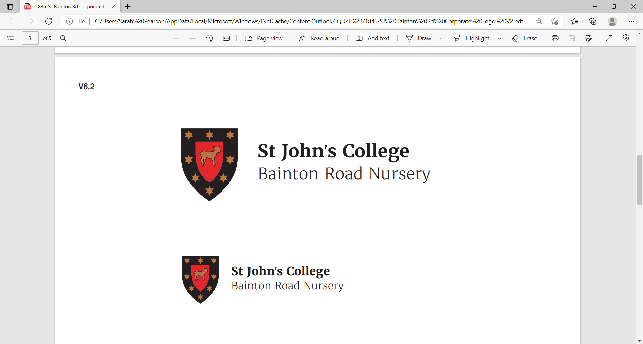

APPLICATION FORM
POST APPLIED FOR:
PERSONAL DETAILS
Title: Forenames:  (Please include middle names) | Surname:  Previous Surname:
Current Address:  Number of years at this address:  Date of Birth (optional):  National Insurance No: | Home Tel No:  Work Tel No:  Mobile No:  Email:
Previous Addresses: (if resident at current address for less than five years, please provide any previous addresses during this period
1. 2.
Number of years at this address: Number of years at this address:

REFEREES
Please provide three references (if appropriate, these should include your present employer). Where you are not currently working with children but have done so in the past, one referee must be from the employer by whom you were most recently in work with children. Please note, references will NOT be accepted from relatives or from referees writing solely in the capacity of friends. Please indicate whether we may contact the referee.

Name | Address  (including post code, tel no, and email address) | Position/Relationship to you

FORMAL EDUCATION
Senior/Secondary School (Name and Address)
O-Level/GCSE Subjects (with dates/grades) | A-Level Subjects (with dates/grades)
University, College, Further Education (Name and address)
Subjects taken:
Qualification:

EMPLOYMENT
Please enter your present employment first; part-time employment should be clearly indicated
Present post and salary | Name of Employer | Date in post:  From and to | Duties | Reason for leaving
Previous Posts | Name of Employer | Date in post:  From and to | Duties | Reason for leaving

OTHER RELEVANT EXPERIENCE, INTERESTS, SKILLS, QUALIFICATIONS e.g. First Aid, Driving licence

PERIOD OF UNPAID ACTIVITY
Please give details of periods not spent in full-time or paid employment
From
To

If appointed, when could you begin ? What is your required period of notice ?
Are you eligible for employment in the UK? Yes No
Do you have any restrictions on taking up employment in the UK? Yes No
(e.g. time limit/visa)

It is important that you provide us with legally accurate answers. Upfront disclosure of a criminal record may not debar you from appointment as we shall consider the nature of the offence, how long ago and at what age it was committed, and any other relevant factors. If necessary please submit the information requested below in confidence, enclosing details in a separate sealed envelope; this will be seen and then destroyed by the Directors of Bainton Road Nursery Ltd.
Please disclose any unspent convictions, cautions, reprimands or warnings. Please note that the amendments to the Exceptions Order 1975 (2013) provide that certain spent convictions and cautions are 'protected' and are not subject to disclosure to employers, and cannot be taken into account. Guidance and criteria on the filtering of these cautions and convictions can be found at the Disclosure and Barring Service website. www.gov.uk/dbs.
You should be aware that Bainton Road Nursery Ltd will institute its own checks on successful applicants for short listing with the Disclosure and Barring Service. Failure to declare any convictions (that are not subject to DBS filtering) may disqualify you for appointment or result in summary dismissal if the discrepancy comes to light subsequently.

DECLARATION
I have not been disqualified from working with children, am not named on the Disclosure & Barring Service Children’s Barred List or the Protection of Children Act List, am not subject to any sanctions imposed by a regulatory body (eg the Teaching Agency)

Please tick one box:
- I have nothing to declare or

- I enclose a confidential statement in a sealed envelope marked confidential.
I understand that any deliberate mis-statement or concealment may disqualify me from being considered for this job, or lead to my dismissal if discovered after my engagement.

Signed* Name Date
*Please note: If the application is submitted electronically, you will be requested to sign the form if called for an interview.
Data Protection Act 1998: The information or data which you have supplied may be processed and held on computer, and will be processed and held on your personal records if you are appointed. The data may be processed by the nursery for the purpose of equality monitoring, compiling statistics, and for the keeping of other employment records.
By signing and returning this application form you will be deemed to be giving your explicit consent to processing of data contained or referred to on it, including any information which may be considered to be sensitive personal data.
Bainton Road Nursery Ltd is committed to safeguarding and promoting the welfare of children and applicants must be willing to undergo child protection screening appropriate to the post, including checks with past employers and the Disclosure & Barring Service.
Please email this application to HR@sjc.ox.ac.uk by Friday, 29th January, 12 noon.

