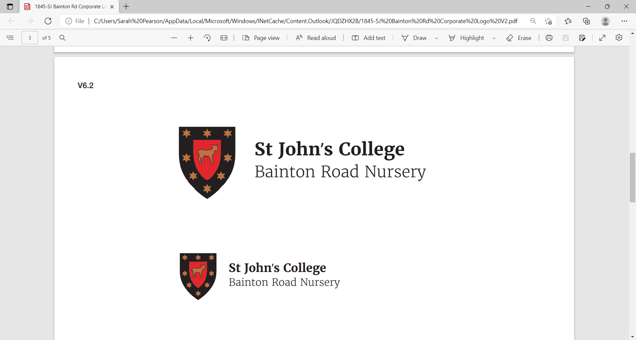
Nursery Manager
St John’s College

Salary: £45,000 - £50,000 (depending on experience and highest qualification)
Department: Bainton Road Nursery
Reports to: Domestic Bursar
Hours: Full-time, 45 hours per week 8.00 am - 6.00 pm
Location: Bainton Road Nursery

Bainton Road Nursery
Bainton Road Nursery is a purpose-built and state-of-the-art facility to cater for the children of students and staff of St John’s College, Oxford, with some places also available for children of Oxford University staff and students. Located just off the Woodstock Road at the northern end of the St John’s College Sports Ground with excellent transportation links. The building has an external play area, facing out over the College sports fields, that is partly covered and can be used all year round. The Nursery is expected to care for approximately 26 children.

Purpose of the Post
St John’s College seeks to appoint an experienced and professional Nursery Manager to join our wonderful nursery. The Nursery Manager will have full day-to-day responsibility for the ongoing running of the Nursery, both operationally and financially, leading the team to offer exceptional childcare in a small, caring and enabling environment. The post holder will report to the Domestic Bursar and will be a member of the college’s Nursery Committee.
The Nursery Manager will be responsible for development and ongoing management of the curriculum, built on a child-centred ethos that recognises the importance of supporting children in developing their early language and communication skills and their all-round development. The Nursery Manager will oversee the marketing of the setting, developing policies, registering new children to the Nursery, meeting OFSTED registration requirements, as well as staff recruitment, training and development.

Main Duties
The Nursery Manager will have full day-to-day responsibility for the ongoing running of the Nursery, both operationally and financially, leading the team to offer exceptional childcare in a small, caring and enabling environment.

Some of your responsibilities will include:

- Ensure the smooth day-to-day running of the nursery
- Promote the safety and welfare of all the children
- Be an inspirational member of the nursery team, supporting and leading staff where necessary and being a role model for good practice.
- Report to and liaise with the nursery committee and keep them informed of any day-to-day issues or problems as they arise.
- Keep and regularly update all paperwork and information regarding the children, their parents and emergency contact numbers, in accordance with Ofsted requirements.
- Ensure that all necessary paperwork is kept and updated on staff, students and volunteers as is required by law and in accordance with Ofsted regulations.
- Day-to-day administrative duties and financial administration
- Deal with any complaints or issues as they arise sensitively and professionally and in accordance with the nursery’s policies. Document any such complaints or issues as required by Ofsted and report them to the Nursery Committee and/or Ofsted as applicable.
- Be available to speak to parents on request, to discuss their child’s progress, or give help and advice on childcare matters.
- Act as the Designated Lead overseeing Safeguarding.
- Generate monthly invoices and apply payments to accounts.
- Create salary sacrifice invoices for payment.
- Ensure a safe and healthy environment for the children and staff. Organise repair work or maintenance as needed.
- Be aware of and address any health and safety issues in accordance with the nursery and College’s health and safety policies and guidelines.
- Carry out risk assessments on all nursery equipment and activities and update these annually, or as required.
- Compile and update a COSHH register.
- Write nursery policies and procedures as required and update these annually, or as required.
- Answer all general email or telephone enquiries about the nursery.
- Attend committee meetings. Give a verbal report to the committee and inform them of any issues that have arisen.
- Ensure lunches for the children are provided, and step into the kitchen in the absence of the nursery chef.
- Organise events for parents to attend with their children throughout the year, such as Christmas plays and nursery outings, in line with statutory guidance.
- Keep registers of children, staff, students and visitors as required by law.
- Take a full and active role in all the nursery routines and rotas
- Liaise with the Domestic Bursar and Nursery committee about the Nursery policy and compliance matters
- To support the adult-to-child ratio when needed for staff absence and lunch cover when needed.
- To organise parent forum meetings to meet with the parent representatives, share ideas and feedback and create an action plan to address items raised.
- Oversee submission of payroll for staff.
- Oversee annual leave requests.
- Oversee analysis of cohort data, creating room development plans.
- Creation of the Continuous Improvement plan, highlighting areas of improvement.
- To role-model good practice to the nursery team.
- To act as a Lead Professional in interagency interventions.
- To identify and support families through the strengths and needs process.
- To oversee funding, confirming eligibility and applying to children’s accounts.
- To maintain the Family Information Service information up to date.
- To carry out annual fee analysis for fee increase consideration.
- To attend inter-collegiate monthly meetings, sharing good practice.
- To ensure the needs of children with SEND are met, following the graduated approach.
- To carry out 12 weekly staff review meetings to support professional development.
- To maintain children’s chronology sheets with relevant information, escalating concerns when required.
- To attend Local Authority network meetings to remain informed of legislative change for implementation.

Selection Criteria
The person appointed will have the following essential qualities:
- A minimum of 2 years' management experience.
- Commitment to keeping up to date with developments in early years care and education
- Strong people management skills and organisational skills with the ability to recruit and support, develop and motivate staff, provide day-to-day guidance, supervision, training and support to all staff, and review team practices
- Achieve and maintain high standards of care and education and a consistent environment for all children and an ability to work with young children and their families in a sensitive and positive way
- Create and implement policies, procedures and curricula, and ensure these are adhered to at all times in line with professional codes and legislation
- The ability to manage the budgets and occupancy levels effectively, with the support of the Domestic Bursar
- The ability to develop strong links with parents, to implement an effective parent liaison programme
- Day-to-day operational management skills, including implementation of admission policy
- Form caring and trusting relationships with both children and families
- Deliver professionalism, service and always maintain confidentiality
- The ability to build good working relationships with relevant agencies, schools and childcare professionals

Essential qualifications, training and skills:
- Early Years Education and Childcare qualification at level 6 or above
- Excellent knowledge of health and safety legislation
- Knowledge of OFSTED standards
- Excellent knowledge of the statutory framework and guidance for the EYFS
- Understanding of safeguarding, child protection and confidentiality
- Knowledge and understanding of equal opportunities / SENCO etc.
- Previous relevant supervisory or management experience
- Excellent time management and organisational skills with the ability to work to targets and deadlines
- Excellent written and spoken communication skills
- Business and budgeting skills
- Relevant experience with IT systems and databases

Desirable qualifications:
- Qualified Teacher Status
- Basic Food Hygiene Certificate
- Paediatric First Aid Trained
- Safer recruitment training

Application procedure

How to apply
We are committed to Safeguarding and promoting the welfare of children and young people and expect all staff and volunteers to share this commitment.
In accordance with Safer Recruitment policy, we will not be accepting CVs for this position. All candidates are required to use the attached Application Form. All applicants are requested to fill in an Equality Monitoring Form to help us fulfil our duties as an equal opportunity’s employer.
The completed Application Form should be returned to vacancies@sjc.ox.ac.uk, or by post to the HR Office, St John’s College, St Giles, Oxford, OX1 3JP, no later than Friday 30th October 2026.
If your application is successful, your appointment will be subject to:
- the provision of an original document which indicates your right to work in the UK,
- the completion of an initial 6-month probationary period,
- the completion of an enhanced DBS check.

Equal Opportunities
St John’s College is committed to providing equality of opportunity and avoiding unlawful discrimination. The policy and practice of the College require that all staff are afforded equal opportunities within employment and that entry into employment with the College and progression within employment will be determined only by personal merit and the application of criteria which are related to the duties of each particular post and the relevant salary structure. In all cases, the ability to perform the job will be the primary consideration. Subject to statutory provisions, no applicant or member of staff will be treated less favourably than another because of any protected characteristic under the Equality Act 2010.

Data Protection
All data supplied by candidates will be used only for the purpose of determining their suitability for the post and will be held in accordance with the principles of the Data Protection Act 2018, General Data Protection Regulation, and the College’s Data Protection Policy and recruitment monitoring process.

