Organiser (first and last name):

Email address/phone number:

Tutor:

Purpose of function and club/society:

Date:

Time (from – to):

Number of attendees:

Number of external attendees (i.e. non-members of St John’s):

Name of external speaker and their organisation:

Name of room:

________________________________________________________________________________________
Is Permission from a Fellow Needed for Use of Room?
Is the room requested subject to authorisation by a Fellow? The list of Authorisations is shown in the Room Booking Guide for Students.
Is Room Authorisation required?:
Is Room Authorisation given?:
Name of Authoriser. Date.

Decanal Permission
Decanal permission WITH 7 DAYS’ NOTICE is required if any of the following apply:
-your function has more than 20 attendees
-involves external attendees (non-members of St John’s) or an external speaker
-alcohol is to be consumed.
Is Decanal permission required?
Is Decanal permission given?
Name of Junior Dean:

Signature of Junior Dean: Date:

Decanal Notes.

_____________________________________________________________________________________
Catering Requirements? (Charges Apply)
Water, Tea, Coffee, Biscuits etc. required?
For other Catering requirements, contact the Catering Office at: catering.office@sjc.ox.ac.uk
______________________________________________________________________________________
Is Room Set Up Required?
If basic room set up is required, please select layout below.
Number of people layout needs to seat?
Is equipment required, please select. Slide Clicker DVD Playback
Laptop Projector Speakers Paper and Pens Screen

For more complex requirements, please contact the Domestic Stores at: stores.management@sjc.ox.ac.uk
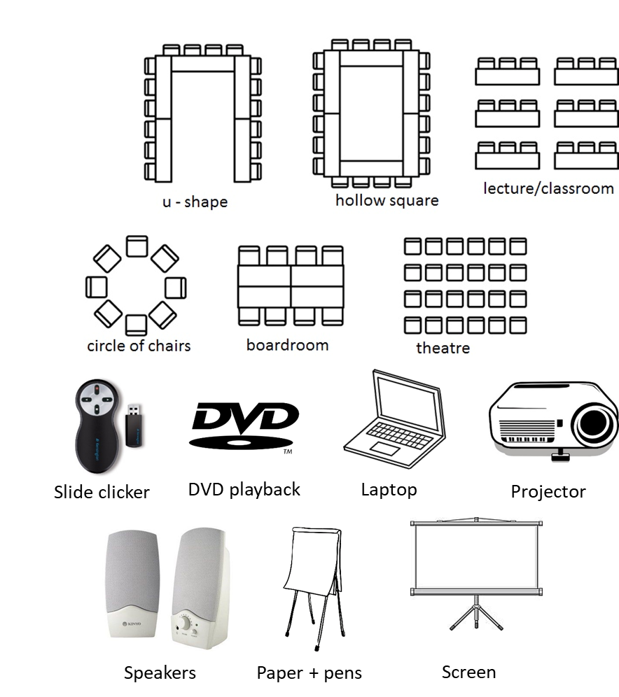

_____________________________________________________________________________________________

Permission from the Principal Bursar must be obtained if you wish to film the event.
__________________________________________________________

